PRISMATIC HERETIC

“Three Swords, One Heretic, No Mercy”

# 

# Sigma Squad

Adrien Kamran - 40095393

Mohamad Ghanmeh - 40062339

Dominique Cartier - 40155296

Jennifer Osorio - 40127009

Dann Kaoussarani - 40133457

Le Cherng Lee - 40122814

# Table of Content

**Executive Summary** **3**

**Overview** **4**

**Player Composites** **6**

**World** **7**

**Characters** **8**

The Heretic (“Three Dots McGee”) 8

The Headmaster (“Monti Falanx, Harbinger of Wrath”) 8

**Progression** **9**

**Art Direction** **10**

Feedback and Sound Effects Tables 12

**UI Storyboards** **14**

**Tags and Dialogue** **15**

Introduction 15

During black screen 15

Blue Sword Level 15

At pedestal 15

At first gap 15

At moving platform pit entrance 16

At middle wall before exit 16

Blue To Yellow Transition 16

At hallway 16

Yellow Sword Level 16

At pedestal 16

At third room 17

At fifth room 17

Yellow to Red Transition 17

At hallway 17

Red Sword Level 17

At pedestal 17

At first arena (Blue) 18

At second arena (Yellow) 18

At third arena (Red) 18

Red to Boss Transition 18

At hallway 18

Final Boss / Headmaster’s Solarium 19

At entrance 19

Outro 19

During black screen 19

**Technology Plan** **21**

Engine / Language 21

Assets 21

Documentation 21

Planning / Communication 21

Version Control 21

**Software Architecture** **22**

**Controls** **23**

**Level Design** **24**

Introduce 24

Demonstrate 24

Experience 24

Practice 24

Test 25

Applied Level Design Philosophy 25

Introduce 25

Demonstrate 25

Experience 25

Practice 25

Test 25

Puzzles (proposed) 26

Levels (actual) 28

**Enemy Archetypes** **29**

FINAL BOSS 30

Mini-Boss Enemies (cut content) 31

**Mechanics Analysis** **32**

Perspective 32

Movement 32

3 Weapon System 32

Pits 35

**Schedule** **36**

# Executive Summary

Prismatic Heretic is a 2D top-down action game set in a world of magic and medieval fantasy with dark academia elements; take on the role of an unnamed heretic, now in possession of 3 holy swords, each with their own unique abilities.

Warp around the arenas, control the flow of battle, and fight on the edge of life and death with the Prismatic Swords system.

Players will quickly realize that the synergy between swords means they can be used in conjunction for much greater results during combat, and for solving otherwise impossible puzzles.

# Overview

**Title** Prismatic Heretic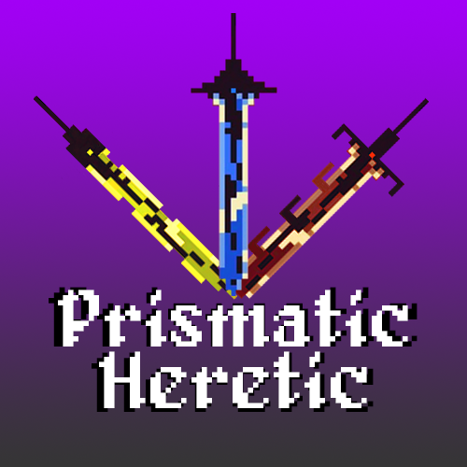

**Tag line** “Three swords, one heretic, no mercy”

**Your name** Sigma Squad

**Genre** Top-down, Hack-and-slash

**Platform** PC

**Market** Teen +



**Setting** High medieval fantasy, gothic academia

**Plays like** Enter the Gungeon meets Wizard of Legend

*Popular Game A Popular Game B or twist*



1. “Twin-stick” movement and aim 3. Leave weapons at your location to be activated later, remotely

2. Switch between 3 distinct weapons 4. Color-coded enemy types, resistant to matching-color weapons

1. [Enter the Gungeon](https://cdn.cloudflare.steamstatic.com/steam/apps/311690/ss_16e5c40621bfb6bfe2b9c010861850595e180e48.1920x1080.jpg?t=1622216602) (weapon use, pixel style) 4. [Dark Souls](https://mocah.org/uploads/posts/4533589-dark-souls-iii-video-games-castle-cathedral-bridge-moon-screen-shot-village-irithyll.png) (Atmosphere)

2. [Wizard of Legend](https://cdn.cloudflare.steamstatic.com/steam/apps/445980/ss_8efdb01e68a2c7a5d2c7570eaaebbb9322c4cdc9.1920x1080.jpg?t=1631898814) (pixel style, environment) 5. [Eldest Souls](https://www.pcinvasion.com/wp-content/uploads/2021/07/Eldest-Souls-quests-special-items-empty-vessel-rewards-guide-.jpg) (Art and inspiration)

3. [Legend of Zelda](https://cdn.gamer-network.net/2016/usgamer/zelda.png) (level layouts) 6. [The Binding of Isaac](https://www.makinggames.biz/wp-content/uploads/2015/05/binding-of-isaac-teaser-neu_9068.jpg) (View and angles)

**Related Games**

1. Enter the Gungeon Dodge Roll Roguelike Bullet Hell/Multiplatform 2016

*Title Publisher or Developer Genre/Platform Year*

Enter the Gungeon is a top-down roguelike bullet hell shooter. Enter the Gungeon’s aiming mechanic is the inspiration for Prismatic Heretic’s aiming system for the blades. Weapons in Prismatic Heretic are not strictly ranged or melee, but having a clear indicator for the direction of the player’s attacks is key; the weapon itself acts as an indicator, in addition to a traditional crosshair. In the heat of the action, where looking for a crosshair in the middle of a swarm of enemies and projectiles could cost the player their life, making the direction of attack be a big glowing sword originating from the player character should increase the readability of the mechanic.

2. Wizard of Legend Contingent 99 Roguelike H&S/Multiplatform 2018

*Title Publisher or Developer Genre/Platform Year*

Wizard of Legend is a top-down roguelike spellcasting action game. The intensity, pixel-based art style, and close-range combat of Wizard of Legend all play a role in the design of Prismatic Heretic. There aren’t any exact mechanics or art assets taken directly from this game, however it acts as an important source of inspiration when referencing the aesthetics and environmental design.

3. Legend of Zelda Nintendo Action Adventure Dungeon Crawl/NES 1986

*Title Publisher or Developer Genre/Platform Year*

Legend of Zelda is the first of its kind, a top-down action adventure dungeon crawling game where the player character’s strength and set of skills grows as the player progresses through the game. It is the great-great-grandfather of the genre, so nearly all of its mechanics can be found in some way in Prismatic Heretic. For example, enemies being resistant/invulnerable to specific weapons forces the player to be creative or change tactics; this is the moment-to-moment gameplay of Prismatic Heretic.

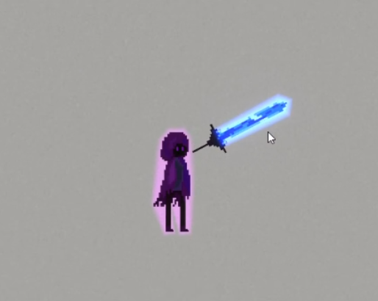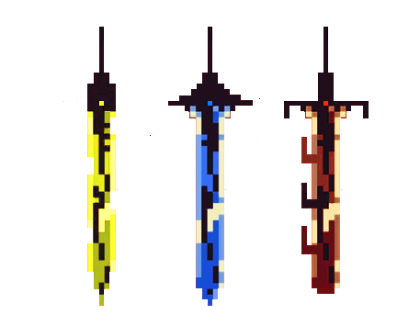



# Player Composites

OLDEST:

* Has seen the birth of the top-down roguelike genre.
* Is intensely familiar with the setting, mechanics, and story tropes before even playing the game for the first time.
* Has less time to play games in general, but wants to be invested enough to have a special experience with the game being played.
* Not strictly looking for realism or super-high difficulty, would prefer an immersive story and environment over complex/demanding mechanics.

MIDDLE:

* Your average college-age student.
* Familiar with video games of all genres and styles.
* Has a good general understanding of fantasy/medieval stories and their tropes.
* Wants to be immersed in the game, both in gameplay and in story.
* Has had enough time in their life to be above-average mechanically for games, expects a challenge from the game being played.

YOUNGEST:

* A middle-teenager, hyper-aware of the trends in gaming.
* Less familiar with the history of the top-down roguelike genre, but most likely exposed to the fantasy/medieval setting by proxy.
* Has the most amount of free time for gaming, is very mechanically skilled in any game they play.
* Wants a fun game first and foremost; the story is secondary to the gameplay for them.

# World

In an era long gone, in a place far removed from here…

The Way of Blue, the Crimson Court and the Sunlight Council. These three distinct schools of magic have emerged, and each has forged holy weapons of immense power; for each, a sword imbued with the school’s core magical abilities. One would hope that these powers would be used for good.

However, one knows that the world has almost always been one of haves and have-nots. The Trisect Academy, home of these powerful schools of magic, has made it their mission to keep it that way. By keeping the holy weapons of each school under lock and key in the Academy, and by planting the seeds of magical power in the minds of a select few students, the Headmaster has ensured that this imbalance of power remains in the Academy’s favor. Until now.

Our protagonist has had enough of the status quo. Having snuck into the Academy under the guise of becoming a magical apprentice, the protagonist has stolen the three holy swords. At the cost of being known forever as the Heretic, the protagonist sets out to rid the Academy of the Headmaster and restore the balance, once and for all.

# Characters

## The Heretic (“Three Dots McGee”)

This is the protagonist of our game. Not belonging to any one school of magic, it doesn’t take long for our hero to see the danger in one institution having control of the world’s most powerful magical knowledge and artifacts. The Heretic uses telekinesis to wield weapons, and has some natural agility, allowing for quick dashes. Not much is known about the Heretic’s identity... The moment the Prismatic Swords were stolen, our hero’s true identity no longer mattered.

With the Headmaster being out of reach for the vast majority of magic-wielders, much less regular folk, it will take some serious fighting to get to the top of the food chain and stop the Headmaster in their tracks.

## The Headmaster (“Monti Falanx, Harbinger of Wrath”)

This is the principal antagonist of our game, named after their position at Trisect Academy. Seizing the opportunity to gain nearly unlimited leverage over some potential academic rivals, the Headmaster convinced the three biggest schools of magic to consolidate and hone their skills in one location, in exchange for having their holy weapons be off-limits. A direct consequence of this action was that the Headmaster was, for all intents and purposes, the most powerful individual in the realm by holding all the proverbial cards. It didn’t take long for the Headmaster to take full advantage of this situation...

# Progression

For the sake of demonstrating our game, the following diagram shows the flow between levels, menus and non-gameplay sections (cutscenes/dialogue). Player character death results in the player being sent back to the Main Menu, and is given the option to return to the last played level with the “Continue” button, as well as the option to start over if desired.

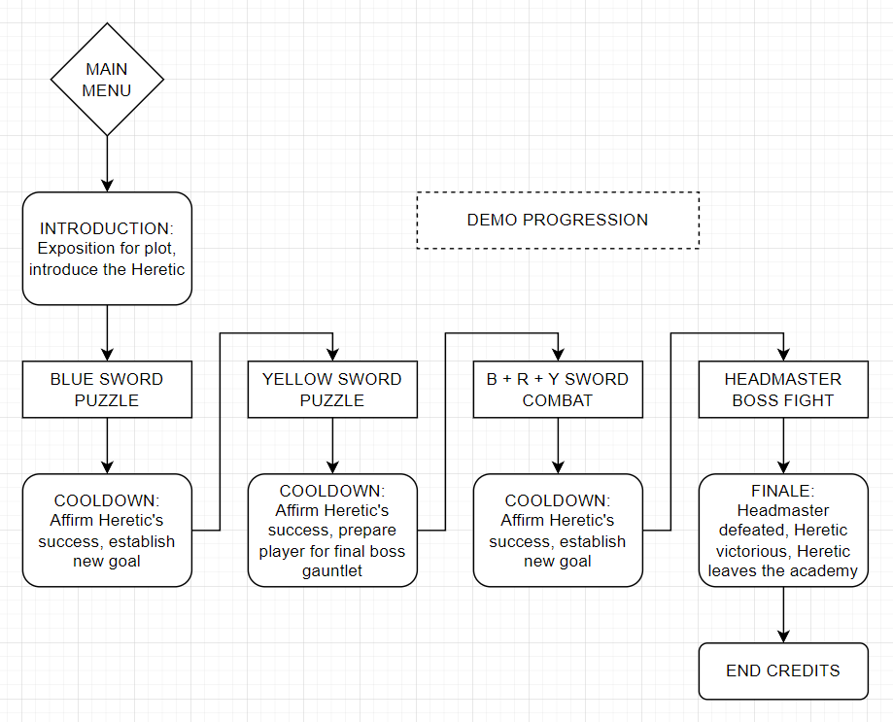

In an ideal scenario, the following diagram shows the full progression for our game. Cut content from the demo (see mini-boss archetypes, etc.) can be found later in the document, and is referenced in this diagram.

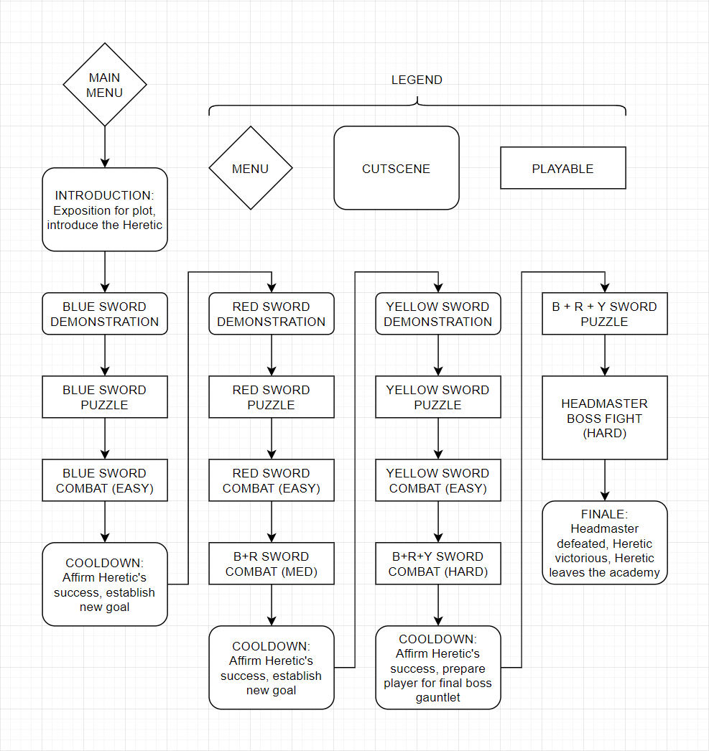

# Art Direction

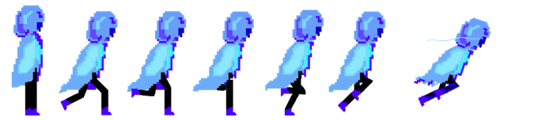

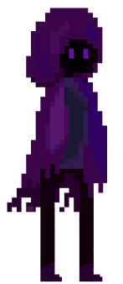 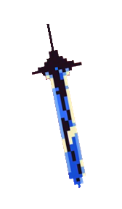 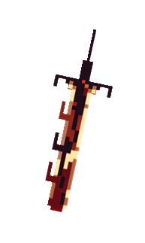 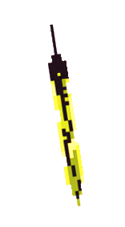

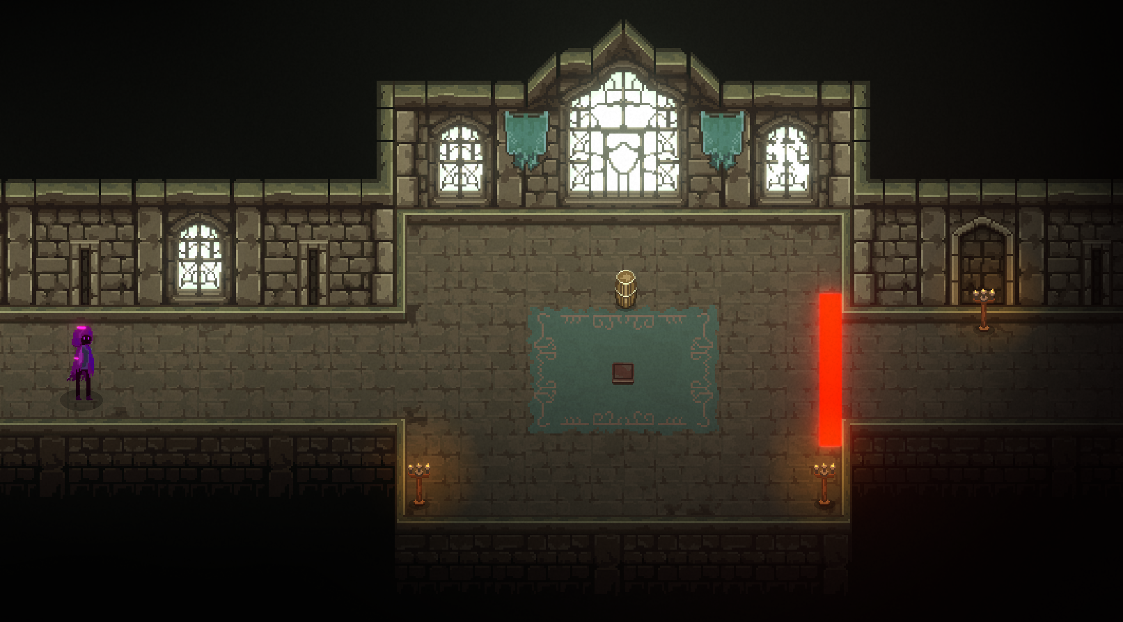

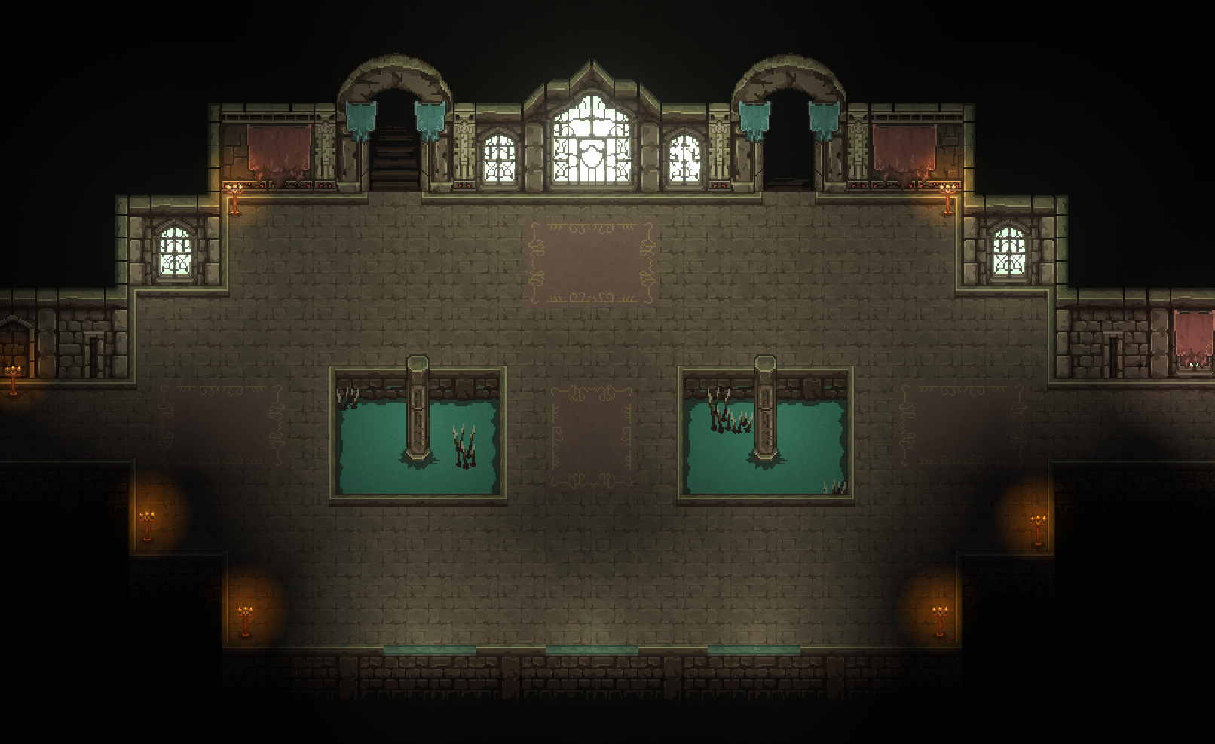

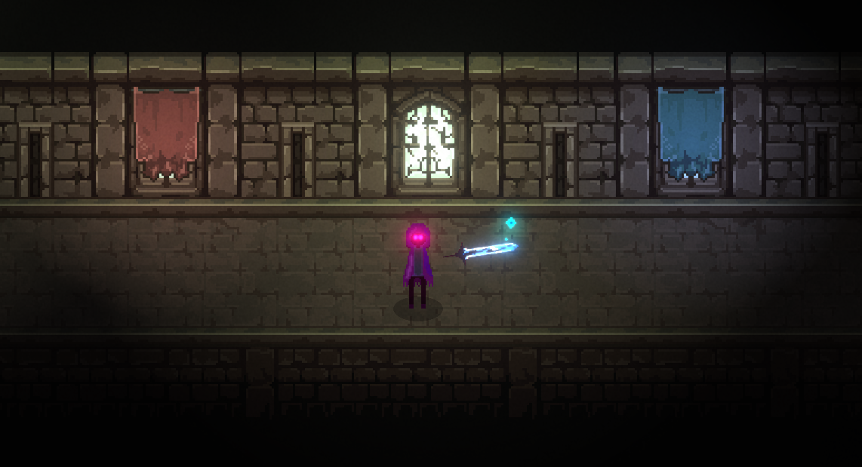

## Feedback and Sound Effects Tables

| FEEDBACK TABLE FOR SWORDS | IDLE | FEEDBACK DURING ACTION | FEEDBACK SUCCESSFUL | FEEDBACK FAILURE |
| --- | --- | --- | --- | --- |
| VFX | Constant particle emission | BLUE:   * Strike: blue slash, glows * Special: sword flies towards direction   YELLOW:   * Strike: place orbs, upon 3 orbs, triangle formed * Special: projectile flies towards direction, with particles * Activate: yellow flash and particles   RED:   * Strike: red slash, glows * Special: eyes glow red, red particles emitted from feet * Activate: particles spawn, then converge on a point | BLUE:   * Strike: eyes glow blue, and blue particles emit from body   YELLOW:   * Strike: each trapped enemy produces 20 particles which flow into player * Special: enemies are marked in gold, objects are frozen   RED:   * Activate: enemy is pulled towards point | Absence of particle effects |
| AUDIO | N/A | PREP FOR ALL SWORDS: metal “cling” sound  BLUE:   * Strike: high-pitch slash * Ability: whoosh + ding + inverted whoosh * Activate: inverted whoosh   YELLOW:   * Strike: short high pitch beep * Ability: pew * Activate: electric shock explosion   RED:   * Strike: low-pitch slash * Ability: thump + heartbeat * Activate: explosion | YELLOW:   * Collected particles make high-pitch “ding” sound | N/A |
| ANIMATION | Follows the mouse | STRIKE FOR BLUE + RED SWORDS:  Sword quickly rotates 75 degrees, then reverts | N/A | N/A |

# UI Storyboards

Main Menu splash screen

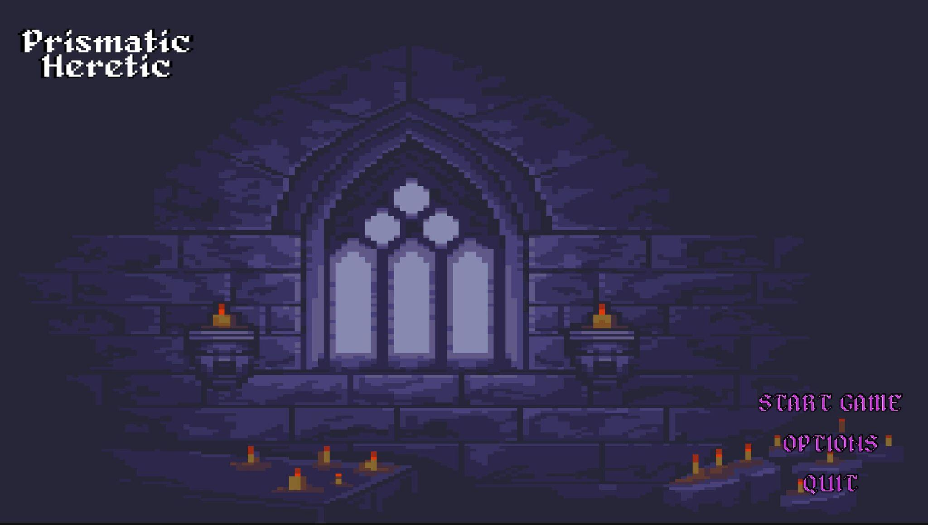

HUD health, stamina and sword availability indicator

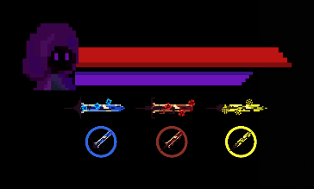

Pause and Game Over pop-ups

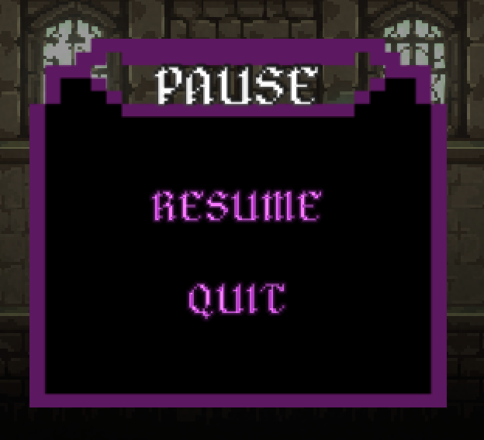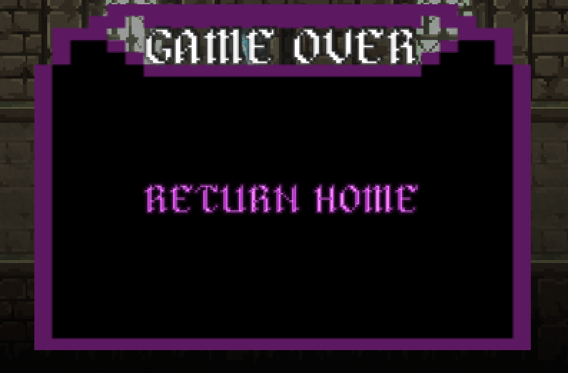

# Tags and Dialogue

## Introduction

### During black screen

In an era long gone, in a place far removed from here…

The Way of Blue, the Crimson Court and the Sunlight Council. These three distinct schools of magic have emerged, and each has forged holy weapons of immense power; for each, a sword imbued with the school’s core magical abilities. One would hope that these powers would be used for good.

However, one knows that the world has almost always been one of haves and have-nots. The Trisect Academy, home of these powerful schools of magic, has made it their mission to keep it that way. By keeping the holy weapons of each school under lock and key in the Academy, and by planting the seeds of magical power in the minds of a select few students, the Headmaster has ensured that this imbalance of power remains in the Academy’s favor. Until now.

Our protagonist has had enough of the status quo. Having snuck into the Academy under the guise of becoming a magical apprentice, the protagonist has a one-track mind: steal the three holy swords, and rid the Academy of the Headmaster. At the cost of being known forever as the Heretic, the protagonist must restore the balance of this world, once and for all.

## Blue Sword Level

### At pedestal

“The Way of Blue really wasn't overselling the beauty of this relic... “

“It’s radiating a kind of magical energy, nothing like the kinds I’ve practiced before.”

“Somehow, I feel lighter around it. My cloak is moving as if there was a breeze, but I don’t see any open windows…”

“I think I’ve taken enough time to admire this thing. Time to take it and put it to use!”

[LMB to swing the sword, gaining movement speed upon damaging an enemy]

[RMB to throw the sword and teleport to its first point of contact]

### At first gap

“This gap goes way too far down for me to even see the bottom.”  
“It doesn’t take a genius to know that I wouldn’t survive a fall like that, even with this sword.”

“Wait, this sword… Rumor has it, it’s light enough to throw like a spear.”

“What would happen if I threw it across this gap?”

### At moving platform pit entrance

“And here’s the infamous training room… Why is it so dark here?”

“I need to be careful not to miss a step, it’s a long way down.”

“Those platforms look like they can get me across.”

“No, wait. What’s with those force fields? I don’t think throwing the sword at them will be of any use.”

“Those blue candelabras look like the only things my sword can reach. I should be able to use them to move between platforms.”

### At middle wall before exit

“Only one wall between me and the exit…”

“This platform is moving freely under the wall, but I’ll fall off if I stay on it.”

“There’s just enough space to lay the sword flat on the platform, though. Hmm…”

[Q to prepare the sword]

[E to activate all prepared swords]

## Blue To Yellow Transition

### At hallway

“One sword down!”  
“It’s no wonder the Headmaster wanted this sword so badly. A relic like this has too much power for any individual.”

“What does that make me, then?”  
“...”

“...”

“No... I can’t forget my mission.”

“Get the swords, take down the Headmaster, lose the swords forever.”

“Next, the Sunlight Council…”

## Yellow Sword Level

### At pedestal

“I have the Sunlight Council to thank for that healing magic back home. All those cuts and bruises during training would have hurt a lot more otherwise…”

“This relic is their pride and joy, and that comes as no surprise.”

“Its golden glow is calming, like the late hours of the afternoon where the sun has only just begun to think about setting.”

“Is it even right to call this a sword? It doesn’t even have a hilt…”

“Whoever designed this knew that it wasn’t made to hurt anyone. However, touching the blade with my bare fingers lets off a shock of electricity, numbing them temporarily.”

[LMB to place an orb on the ground; enemies caught within the area marked by the orbs are damaged, and you are healed proportionally]

[RMB to fire a beam which marks and paralyzes enemies; damage marked enemies to heal yourself during combat]

### At third room

“This floating orb seems to be triggering those pressure plates like the barrels...”

“I might be able to freeze it in-place with this sword. It won’t last forever, but maybe long enough to get through!”

### At fifth room

“Another blue force field… There’s no way through with just one barrel.”

“These swords are heavy enough to hold these pressure plates down, though.”

## Yellow to Red Transition

### At hallway

“That’s the second sword done with. Only one to go, now.”

“I wonder, what was it that convinced the Sunlight Council to hand themselves over to the Headmaster of the Trisect Academy?”

“Surely, with all their good will, they wouldn’t have to make themselves subservient to a tyrant like the Headmaster in order to survive.”

“The only alternative I can think of is that they were duped. Nothing worse than a liar with leverage.”

“I hope I won’t have to cross paths with any of their disciples, much less cross swords…”

## Red Sword Level

### At pedestal

“This thing… It has the general shape of a sword, at best.”

“But there’s something wrong with it. Many things wrong with it.”

“It’s too big, too thick, too heavy, and too rough. It’s more like a large hunk of blood-red iron that’s been cut into aggressively, forming these teeth, like a saw.”

“And that energy… It’s like it’s constantly screaming. Not at me, but at everything. I feel rage just by being near it.”

“It’s a holy item in name only. By taking this, I’m damning my enemies as much as I’m damning myself.”

[LMB to swing the sword, at the cost of your health per swing]

[RMB to toggle rage mode, at the cost of your health over time]

“...”

“To say this place is desolate is an understatement…”

“How could the Headmaster allow for such disrepair to run rampant?”

“Is this what the Crimson Court wanted from the start?”

### At first arena (Blue)

Blue: “Halt! Who goes there?”

Heretic: “I’m here for the Headmaster. Make way, this is not the Way of Blue’s concern.”

Blue: “You expect us to turn on the one person who gave us a place to thrive? Don’t blink, or you might just miss the moment you die…”

Heretic: “You asked for it!”

### At second arena (Yellow)

Yellow: “Your robe, I’ve never seen one like it… What brings you here, wanderer?”

Heretic: “Disciples of the Sunlight Council, I have no quarrel with you. It’s your Headmaster that needs to learn a lesson.”

Yellow: “Even so, stranger, we cannot let you pass. You know what you did by entering these grounds unwelcomed.”

Heretic: “It didn’t have to be like this…”

### At third arena (Red)

Red: “An intruder in our domain… If it’s death you seek, you are most welcome…”

Heretic: “The Crimson Court truly has a way with words. I suppose you won’t let me pass without a fight?”

Red: “Destroy the intruder, crush their soul! Your blood will serve us well!”

Heretic: “Careful, with all that anger, you might just spill your own!”

## Red to Boss Transition

### At hallway

“So, that was the last sword…”

“That thing is a mess. Carrying this sword around is draining, both mentally and physically.”

“The less time I spend around this cursed thing, the better.”

“At least I can take some comfort in knowing that the Headmaster isn’t using this. Knowing the Crimson Court, I should have seen this coming…”

“...”

“What am I doing? I have the blood of all three schools of magic on my hands now.”

“This madness has to end.”

“The Headmaster must fall.”

## Final Boss / Headmaster’s Solarium

### At entrance

Headmaster: “Word travels fast in these hallowed halls, Heretic.”

Heretic: “...”

Headmaster: “A fledgeling mage, carving a path through the cobblestone and tiles of the Trisect Academy, ending the lives of many disciples, and for what?”

Heretic: “...”

Headmaster: “You would be a fool to believe that those relics will be of any use to you. Without training, commitment, sheer will, you are holding three twigs at best.”

Heretic: “If you’re so confident, why even keep these weapons from the disciples in the first place?”

Headmaster: “Power is not simply a sum. It is the difference between what you have and what others do not. And as of this moment, I find you quite lacking.”

Headmaster: “Allow me to demonstrate what TRUE power looks like. Pay close attention, young one. This will be your first and last lesson.”

## Outro

### During black screen

The Headmaster, collapsing from exhaustion, succumbing to the stresses overcoming a once powerful body, gives into the darkness and slumps onto the cobblestone floor.

“How…?,” the Headmaster asks, barely perceptible. “You’re just a child… What gives you the authority to face me and win? Who trained you? Who sent you?”

The Heretic does not speak.

Instead of answering, the Heretic carefully places a trio of golden orbs in a triangle pattern, surrounding the weakened body of the Headmaster.

The Headmaster coughs, anger seeping into a once calm voice.

“Answer me... Answer me, peasant! Was it the Foreign Kingdoms? The Duke from the North? The Western Alliance? They would do anything to obtain what lies between these sacred walls. You fail to even begin to comprehend the chaos you are unleashing!”

The Heretic continues the silence.

Once again, instead of answering, the Heretic lays the relics of the Sunlight Council and the Crimson Court at the Headmaster’s chin.

The Headmaster begins to desperately squirm in place.

“What is it you want? Riches? Relics? Records? You can have them, I don’t care. You have shown me enough disinterest to last the both of us a collective lifetime. Just know that you will never live up to the power you have just gained, and that the vacuum you are leaving behind will be filled quicker than your puny existence can even imagine. You are just as lost now as you were when you weaseled your way in here.”

The Heretic takes position, facing the Headmaster head-on, the Way of Blue’s holy relic in hand. The Headmaster’s body goes limp, abandoning the pretense of resistance.

“Go on. Do it. What’s this but one more life for you to snuff out?”

The Heretic obliges.

The three golden orbs shimmer in unison. A flash of light erupts, and the Headmaster’s body is frozen in place by two of the relics. A thrown sword makes impact, shattering the Headmaster into pieces of pieces.

The Headmaster’s solarium is now the home of a single living occupant.

A fine, shimmering dust swirls around the Heretic. The winds of fate point in a direction. The Heretic follows, never to return.

# Technology Plan

## Engine / Language

As per the requirements, Prismatic Heretic is being developed in the Unity engine (2020.3.17f1). The engine uses the C# object-oriented programming language. Considering our team’s common experience with OOP, C# is a natural choice of language, and Unity’s powerful editor speeds up the development process by a lot.

## Assets

The 16x16 tileset used for the environmental design is from the [Rogue Fantasy Castle](https://assetstore.unity.com/packages/2d/environments/rogue-fantasy-castle-164725) asset pack provided for free by Szadi Art on the Unity Asset Store. Every other asset in the game is original, and has been designed by members of our team in the software of their choice. Examples include Photoshop and Procreate for pixel art.

## Documentation

Our Game Design Document is being written (and collaborated on remotely) using Google Docs.

## Planning / Communication

Meetings between all of the team members take place at least once a week for an hour, either remotely or in person depending on our schedules. Smaller meetings (between two or three members) take place more frequently during the week, often for longer periods of time (at least one hour, up to four). Communication is maintained using a Discord server exclusive for our team.

## Version Control

The project’s parallel development is possible thanks to Git, and tracked with Github.

# Software Architecture

The architecture of our game follows the standard OOP development pattern that Unity encourages, with the MonoBehaviour lifecycle applying to most scripts. As the game is developed, a game state manager and event manager will be created to handle the flow between levels and the player’s status.

The A* algorithm is being used to generate and update the paths taken by the enemy NPCs in each scene.

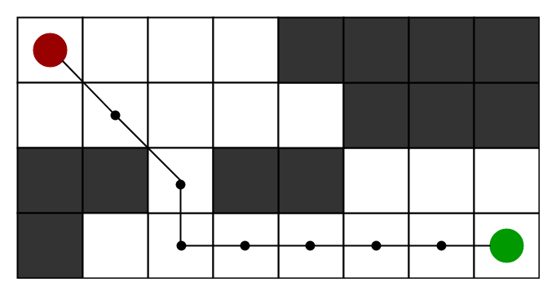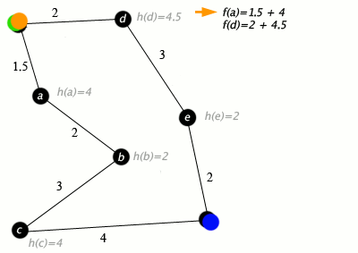

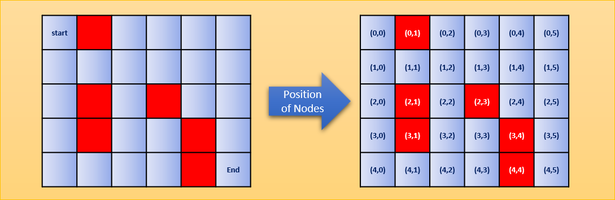

# Controls

Movement:

* W: move up
* A: move left
* S: move down
* D: move right
* LShift: dash

Sword aiming:

* Selected sword’s aiming direction starts from the player character and ends at the player’s cursor on-screen.

Sword selection:

* Numkey 1: select Blue Sword
* Numkey 2: select Red Sword
* Numkey 3: select Yellow Sword

Sword actions:

* LMB: strike
* RMB: special
* Q: prepare
* E: activate

System:

* ESC: pause
* Space: self-damage [DEBUG]

# Level Design

Players should be faced with increasingly complex, challenging and demanding situations as progress is made throughout the game. Simultaneously, players will need to be introduced to new mechanics progressively, like with a learning curve.

As such, it is necessary to adopt a level design workflow in this document, so that it can be applied in-game. The goal will be to design levels which reflect the phases of learning that the player will experience. In the following example, we’ll be using the [Effect and Cause level from Titanfall 2](https://en.wikipedia.org/wiki/Effect_and_Cause).

### Introduce

Present the player with the mechanic symbolically. This will be through the form of the mechanic, not strictly the function.

EX: a man’s body is found half-stuck in the floor, as if the floor had suddenly materialized itself into it. The player character approaches the body and sees a device strapped to its left hand, something out-of-place for a soldier like him, and takes it for himself.

### Demonstrate

With minimal interaction from the player, show how the mechanic affects the game world. This is where the mechanic’s form communicates the function.

EX: the player character flicks a switch on the device and, instantly, the world around him has been shot back several years in time; the ruined walls, dead plants and smashed windows are suddenly brought back to their former glory. With a second flick of that same switch, the world is brought forward in time, back to the present day.

### Experience

Give the player control of the mechanic in full, but with relatively easy challenges to overcome. The mechanic’s function is finally brought to the forefront.

EX: the player character must progress through a ruined facility to reach his objective. When faced with a caved-in hallway, the player must intuit that using the time-travel device will restore the hallway to its pre-destroyed state, allowing the player to progress through the level.

### Practice

Have the player face an increasingly difficult set of small challenges to put the mechanic to use, ideally with variations in atomic parameters (e.g. timing windows, input frequency, etc.).

EX: the player character’s progress is impeded when he must traverse a lethal set of obstacles: missing platforms, enemy patrols, and pieces of rapidly moving machinery. To advance, the player must be constantly switching between timelines using the device, avoiding enemies in one timeline and using precision platforming skills in another.

### Test

Place the player in a situation where the only way to progress is to use the mechanic to its fullest.

EX: the player character must take a long leap through a dozens-of-meters vertical ventilation tunnel in order to reach the objective room. In the current timeline, debris blocks the path downwards. In the past timeline, the ventilation fans are spinning at full speed. The player character must jump down into the tunnel, where the player must quickly time their use of the mechanic in order to avoid certain death, alternating rapidly between timelines; the player character’s speed increases as he approaches terminal velocity, decreasing the amount of time the player has to react for each obstacle.

## Applied Level Design Philosophy

To demonstrate how the above level design philosophy is used in our game, here is how the Blue Sword Level was designed.

### Introduce

The player is prompted to acquire the sword. The protagonist comments on the sword’s features, and hints towards its abilities. A prompt indicates the controls.

### Demonstrate

To progress, the player must use the sword’s ability in a simple and controlled environment: a gap blocks the path between the player and the rest of the level. Throwing the sword over the gap will result in success.

### Experience

A larger gap (at the bend of a hallway) separates the player from the rest of the level. The player must land on a static platform, meaning that there are two steps for the player to take instead of one.

### Practice

The player is introduced to moving platforms, hovering over a massive pit. They are told that falling off a platform will result in death. The protagonist hints at how the platforms are reachable by throwing the sword at the blue candelabra on each platform, but that walls of blue energy will repel the sword.

### Test

An instant-kill wall separates the player from the end of the level. A platform is found moving under the wall. The protagonist hints at using the preparation/activation mechanic to leave the sword on the platform, then teleport to it once it’s on the other side in order to bypass the wall. This section requires the most skill from the player, and is only achievable with a good understanding of the existing mechanics.

## Puzzles (proposed)

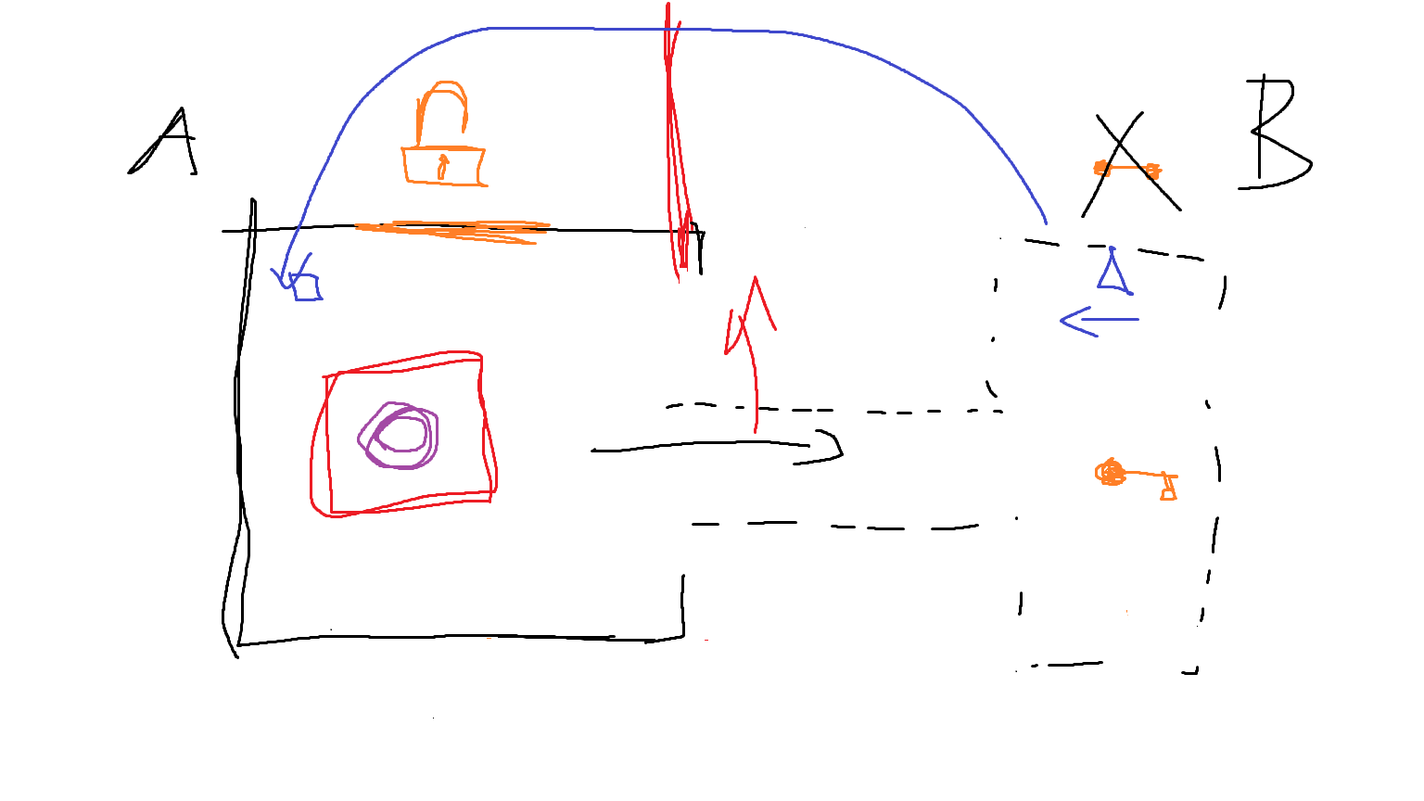

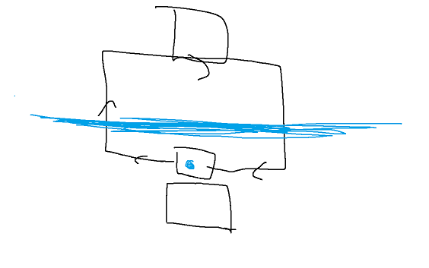

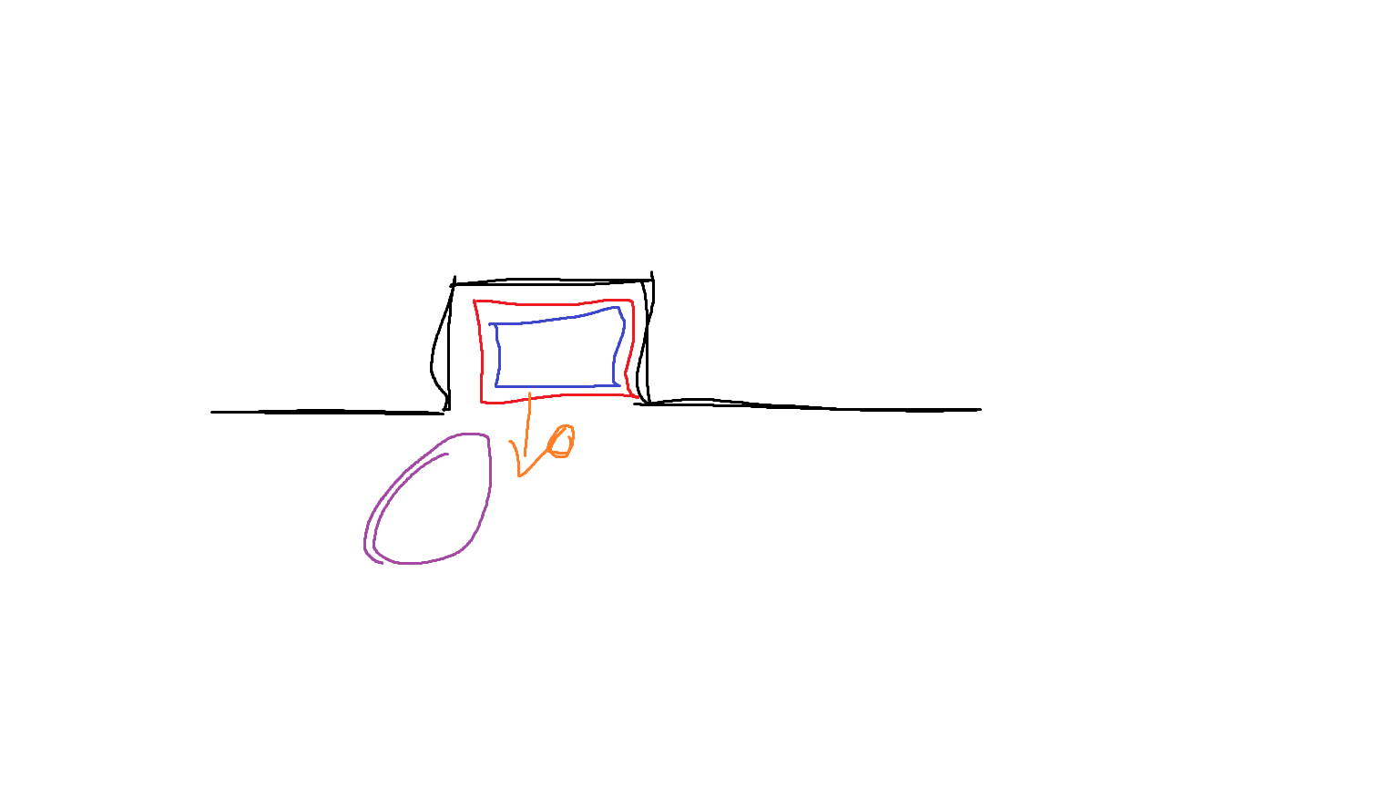

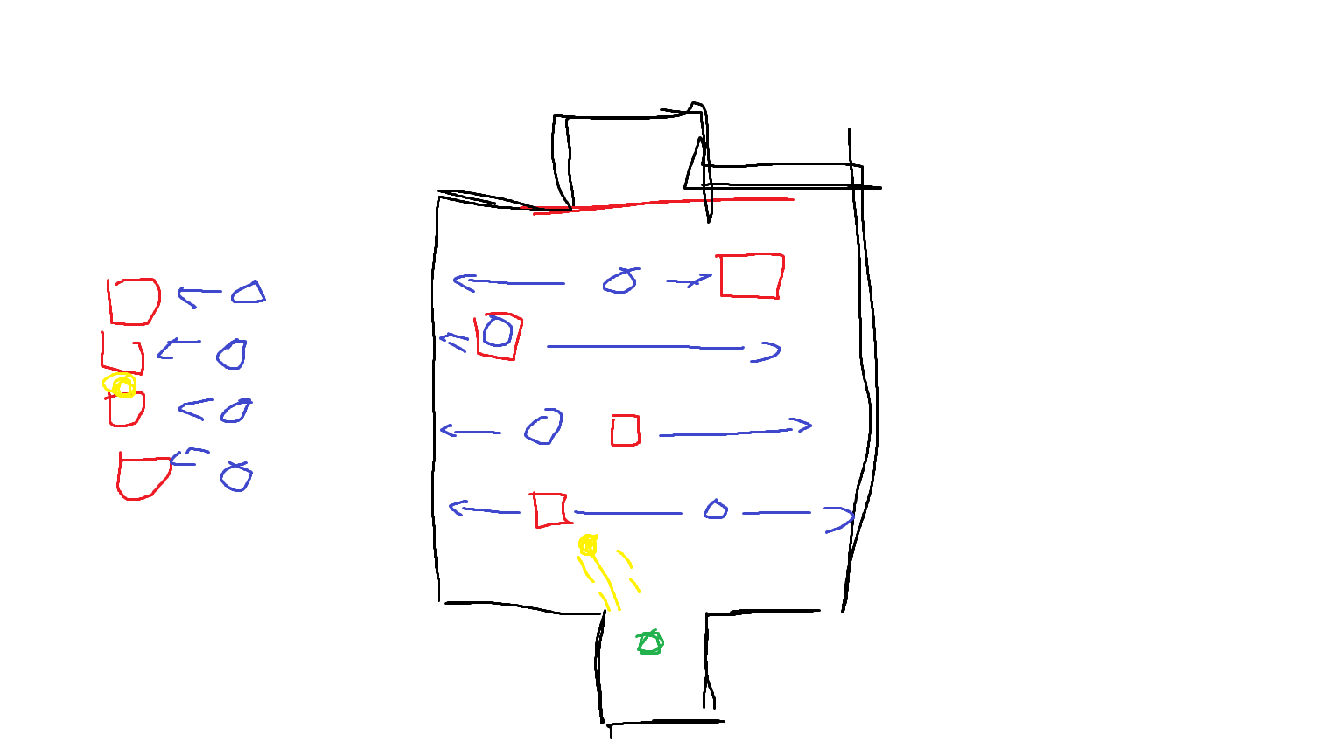

## Levels (actual)

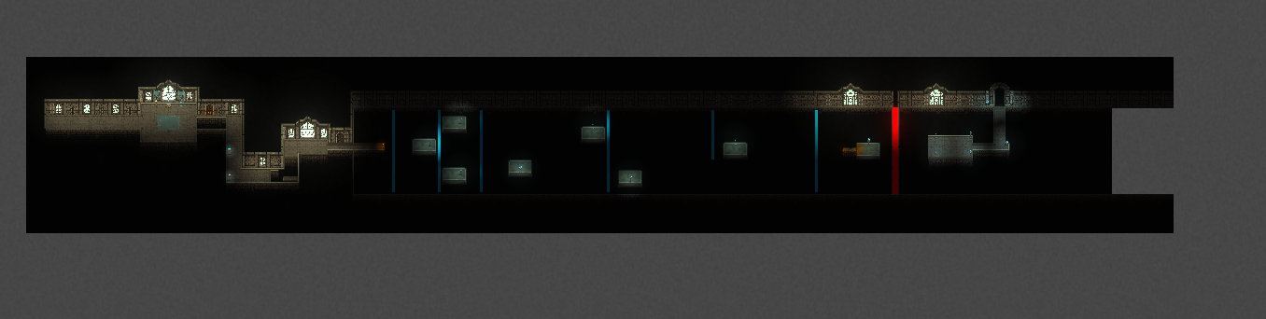

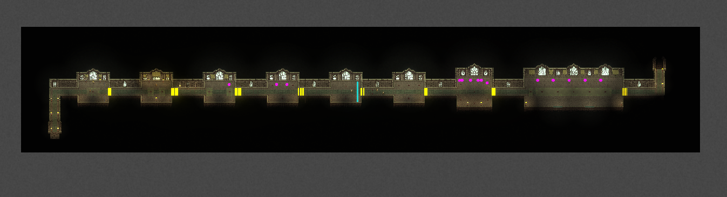

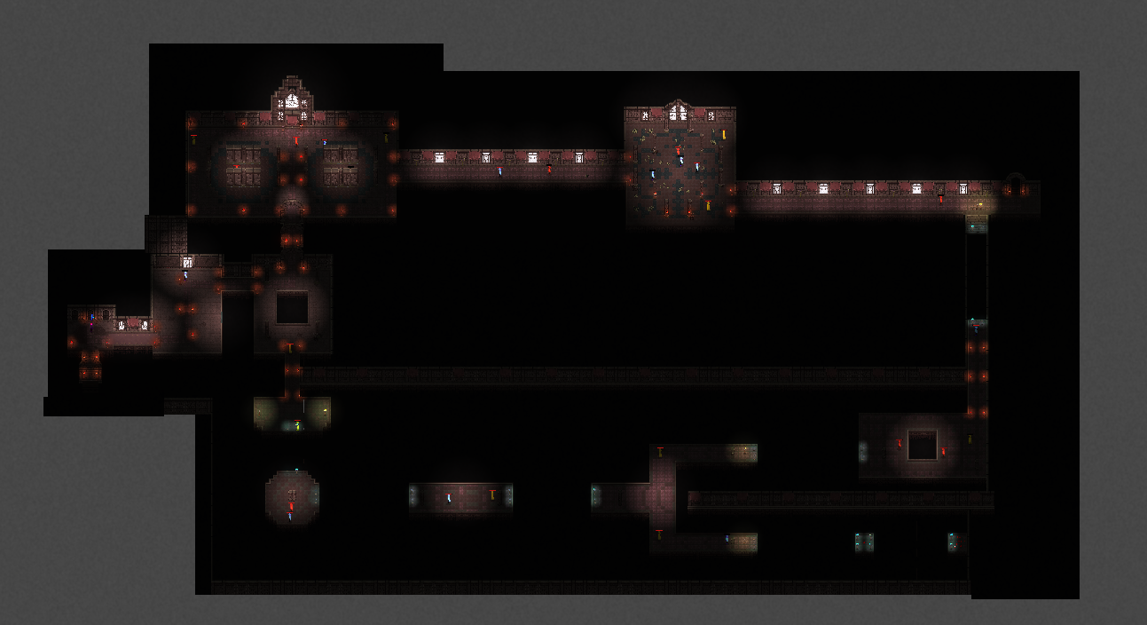

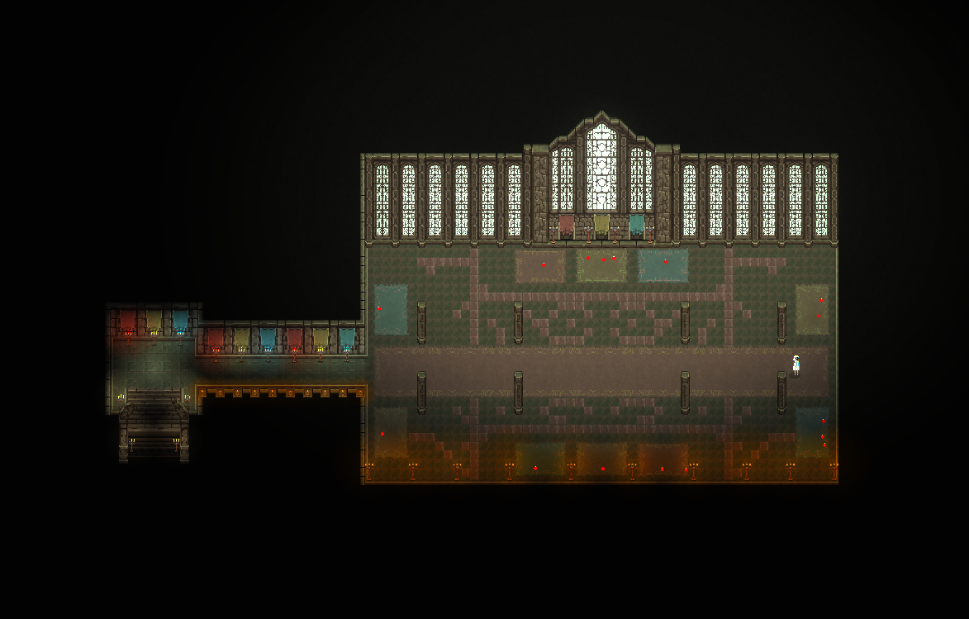

# Enemy Archetypes

| **BLUE MOB** | | |
| --- | --- | --- |
| **Characteristics / Values** | **Qualifier** | **Quantifier** |
| Speed | Fast | 20 units/second |
| Predictability | Easy (straight line) | N/A |
| Window of Opportunity | Small (only damageable by Red) | Always |
| Focus Duration | Depends on weapon | 100 hp |
| Attack | Melee slashes, high frequency. After a confirmed hit, all blue mobs near the player should stay put during the player’s recovery. | Instant, 20 damage |

| **RED MOB** | | |
| --- | --- | --- |
| **Characteristics / Values** | **Qualifier** | **Quantifier** |
| Speed | Slow | 10 units/second |
| Predictability | Easy (straight line) | N/A |
| Window of Opportunity | Always available (only damageable by Blue and yellow) | Always |
| Focus Duration | Depends on weapon | 100 hp |
| Attack | Arc swings with knockback, stun the player on hit | Instant, 20 damage |

| **YELLOW MOB** | | |
| --- | --- | --- |
| **Characteristics / Values** | **Qualifier** | **Quantifier** |
| Speed | Same as player | 10 units/second |
| Predictability | Medium (picks a point behind the mob to flee too, opposite the player) | 10 units behind itself |
| Window of Opportunity | Medium (always at range, can be damaged by Blue or Red) | Always |
| Focus Duration | Depends on weapon | 100 hp |
| Attack | Ranged projectiles, lower frequency than player | 20 units/second, 20 damage |

### FINAL BOSS

Starting at 1000 health…

ALL PHASES:

* Projectile shots (2 variations, small/large orb)
* Projectile patterns alternate between leading and radial (8 in 8 directions)
* Projectile fire rate is one shot every 1.5 seconds, if too far for melee

WHITE:

* 50/50 teleportation every 5 seconds to a point (⅙ fixed points on the map, ¼ positions around the player)
* Red strike attack (hits have knockback)
* Base speed 20 units/second

BLUE (at 900 health):

* Immune to blue sword attacks
* Speed increased to 25 units/second
* 100% teleportation every 2.5 seconds
* Attacks have smaller hitbox, but no knockback

YELLOW (at 500 health):

* Immune to yellow sword attacks
* 50/50 teleportation every 5 seconds
* Speed of 20/units a second
* EXCLUSIVELY projectile attacks
* New mechanic, ⅕ fire rate increases to a shot every 0.1 seconds for 3 seconds, then decreasing to every 1 second.

RED (at 200 health):

* Immune to red sword attacks
* Enters berserk mode:
  + HP decreases at -5 HP/second
  + Movement speed increases to 25 units/second
  + EXCLUSIVELY melee attacks
  + Hits have knockback

### Mini-Boss Enemies (cut content)

BLUE: Melee, teleports quickly in and out of melee range. COUNTER: use Red/Yellow Activate to trap the boss in melee range before it strikes.

YELLOW: Ranged, teleports side to side to dodge. COUNTER: close gap with Blue, trap with Red. Non-Yellow enemies must be spawned regularly in the arena to provide healing opportunities for the player.

RED: Slow, constant movement towards the player character. Fires infrequent slow-traveling projectiles which deal high damage and knock the player back. COUNTER: stun with Yellow, damage with Blue, Dash away before boss can hurt you.

# Mechanics Analysis

## Perspective

The game is viewed from the top-down perspective. The camera follows the player character as movement commands are inputted.

## Movement

Movement of all characters is restricted to the 8 cardinal directions:

* Up/Down
* Left/Right
* Diagonals

Movement speed of the player character quickly increases to its maximum limit on input, and quickly decreases to zero on release.

There is no “vertical” (3rd dimension) component to movement.

On input, the player character can Dash in the direction its sword is facing. This acts as an instant movement speed boost (think impulse) to a set multiplied speed above the character’s maximum, then quickly decreases back to the character’s set speed given the input (max in movement, zero when still). Dash is limited by a stamina gauge.

## 3 Weapon System

The main character wields (one at a time) three different weapons:

* Blue Sword
* Red Sword
* Yellow Sword

The player character’s weapon actions include:

* Strike
* Special
* Prep
* Activate

Prep is an action which places the player’s equipped weapon at the player’s location, leaving it behind. The weapon remains immobile and cannot be equipped by the player character while it is Prepped.

Activate is an action which triggers the Prepped weapons’ special abilities.

| **Sword / Action** | **Strike** | **Special** | **Activate** |
| --- | --- | --- | --- |
| **Blue** | A small sword swing which deals damage. On a non-blue enemy hit, the player’s movement speed is increased by a fixed amount temporarily.  15 damage  Blue enemies are not dealt damage if hit, and no speed boost is awarded. | Sword is launched in the aiming direction at a high, constant speed.  Upon hitting the environment (walls, pillars, etc.), or an interactable item (candelabra, barrel, etc.), the player teleports to the spot hit and instantly regains access to the sword.  50 damage  Upon hitting an enemy, the player regains access to the sword. If the enemy is blue, or the sword was thrown from within 5 units away, nothing else happens. If it is not blue, and the sword was thrown from more than 5 units away, damage is dealt. | The player character instantly teleports to the sword’s location, then regains instant access to the weapon. |
| **Red** | A forward slash emits a shockwave outwards from the top of the sword, in an arc.  25 damage non berserk  50 damage berserk  Non-red nemies which get hit by the shockwave are damaged and pushed back a moderate amount. The player character takes some damage regardless of if an enemy is hit or not.  If a Red enemy is Struck with the Red Sword, the enemy takes no damage and is not pushed back. | Berserk mode: while active, deal an increased amount of damage per Red Sword strike. Damage is taken constantly by the player over time until berserk mode is deactivated, or until the player’s health reaches 0.  Take 4 damage per second | The sword pulls all enemies towards it, within a radius (see Diana’s ultimate ability in League of Legends), for a fixed amount of time. Once this time runs out, the player regains instant access to the weapon.  Interactable items in radius are also pulled towards the sword. |
| **Yellow** | A glowing orb is placed at the location of the sword’s tip. Upon placing three orbs, A triangle is formed connecting the orbs. The player steals health from any non-yellow enemies within this triangle area, and the orbs (and triangle) disappear. Yellow enemies are unaffected (they are not dealt damage and the player does not heal).  10 damage Spawns 20 particles that heal for 1 each. | Fires a fast projectile (same speed as thrown Blue Sword) from the tip of the sword towards the aiming direction with no distance limit.  Non-yellow enemies which make contact with the projectile are marked with a golden glow for a fixed amount of time. If a marked enemy is struck with any other weapon, the player character is healed by a fixed amount, and the mark disappears.  If a Yellow enemy is Struck by a projectile, the enemy is not marked.  If a moving interactable item is hit, it freezes in place. An item that has been frozen this way can be unfrozen by hitting it with another projectile. | Non-yellow enemies within a radius from the sword are stunned for a fixed amount of time and marked for a longer amount of time. When the enemies are no longer stunned, the player regains instant access to the weapon.  Yellow enemies in radius are not stunned.  3 second stun |

## Pits

Pits are found throughout the game’s levels and interact with other elements as follows:

| **Player** | **Enemies** | **Interactable items** |
| --- | --- | --- |
| The player dies after 0.1 seconds of contact with a pit (and the corresponding falling sequence plays) | Enemies die upon falling into pits. | Items that fall (or are pushed) into pits immediately respawn at the initial point where they appeared in the world. If the item first rested on a moving platform, its respawn point is adjusted to match the current position of said platform (and thus is local relative to the platform, rather than absolute). |

# Schedule

Meetings between all of the team members take place at least once a week for an hour, either remotely or in person depending on our schedules. Smaller meetings (between two or three members) take place more frequently during the week, often for longer periods of time (at least one hour, up to four).

The most frequent days for meetings are Sundays (remote) and Thursdays (in-person, after the 376 lecture).